Established – 1961 Subject: OS DBMS
SEVA SADAN’S
















OF
ARTS, SCIENCE & COMMERCE ULHASNAGAR-
421003

CERTIFICATE
This is to certify that Mr./Ms. Shreya Pravin Singh of S.Y. Information Technology (SYIT) Roll No. 2542047 has satisfactorily completed the Open Source DataBase Management System Mini Project entitled Sales Data Analysis using GROUP BY & HAVING During the academic year 2025 – 2026, as a part of the practical requirement. The project work is found to be satisfactory and is approved for submission.

PROF. INCHARGE HEAD OF DEPT
SAHIL SHUKLA LAXMI JESWANI

INDEX

Sr. No. | Chapter Title | PAGE NO
1 | Introduction | 3
2 | Problem Definition | 4
3 | Objectives of the Project | 5
4 | Scope of the Project | 6
5 | Requirement Specification | 7
6 | System Design | 8
7 | Database Design | 9
8 | UML Diagrams | 11
9 | SQL Implementation | 15
10 | System Testing and Result | 17
11 | Security, Backup and Recovery | 20
12 | Future Scope and Conclusion | 23
13 | References | 25
14 | Glossary | 26
15 | Appendix | 27

1. INTRODUCTION

Sales Data Analysis System is a database-driven system designed to store, manage, and analyze sales records of an organization. The primary purpose of this system is to help management understand sales performance using SQL analytical operations such as GROUP BY and HAVING clauses.
Sales data includes information such as product details, customer details, sales amount, sales date, and region. In many organizations, sales records are maintained manually using registers or simple spreadsheets. As the volume of sales data increases, manual systems become inefficient and error-prone.
Using a database system allows structured storage of sales data and enables efficient analysis. The GROUP BY clause is used to group data based on attributes such as product, region, or date, while the HAVING clause is used to filter grouped results based on conditions.
MySQL is chosen as the DBMS because it is open-source, reliable, and widely used. It supports powerful SQL features that make data analysis fast and accurate.
Using MySQL as the Database Management System (DBMS), this project stores sales data in structured tables and uses GROUP BY and HAVING clauses to analyze total sales, identify high-performing products, and filter summarized results.

2. PROBLEM DEFINITION

In many organizations, sales data is stored using manual records or basic spreadsheet systems, which makes data management and analysis difficult as the volume of data increases. These traditional methods lack proper structure, making it hard to group sales information by product, region, or time period.
Generating summary reports such as total sales or product-wise performance requires manual calculations, which are time-consuming and prone to errors. Data redundancy and inconsistency are also common due to repeated data entry in multiple files.
Additionally, filtering summarized data based on specific conditions (for example, products with sales above a certain limit) is not efficient without analytical tools like GROUP BY and HAVING. Due to these limitations, organizations face challenges in producing accurate reports and making timely business decisions.
In traditional systems, sales data is stored in unorganized formats such as paper records or spreadsheets. This creates problems such as:
- Data redundancy and duplication
- Difficulty in analyzing total sales by product or region
- No easy way to identify top-performing products
- Manual report generation is time-consuming
- High chances of data inconsistency and human errors
- Lack of historical sales trend analysis
There is a strong need for a structured system that can analyze sales data efficiently using SQL queries. The proposed system uses GROUP BY and HAVING clauses to summarize and filter sales information for decision-making.

3. OBJECTIVES OF THE PROJECT

The objective of this project is to design a database-driven Sales Data Analysis System that performs analytical queries using GROUP BY and HAVING.
The detailed objectives of the project are explained below:
- To design a structured sales database
This objective focuses on creating a well-organized database schema consisting of tables such as Product, Customer, and Sales.
- To store sales data efficiently
This allows easy insertion, updating, and retrieval of data while maintaining accuracy and consistency.
- To use GROUP BY for data summarization
One of the key objectives is to apply the GROUP BY clause to group sales records based on attributes such as product, category, or date.
- To use HAVING for filtering grouped results
The HAVING clause is used to filter summarized data based on specific conditions, such as identifying products whose total sales exceed a certain value.
- To generate meaningful sales reports
The project aims to generate reports that show product-wise sales, customer-wise purchases, and overall sales performance.
- To ensure data integrity and consistency
Another important objective is to apply database constraints such as Primary Key and Foreign Key to maintain accurate and reliable data.
- To gain practical experience in SQL and MySQL
This project helps in understanding how GROUP BY and HAVING are used in real-world data analysis scenarios.

4. SCOPE OF THE PROJECT

The scope of the project is limited to database design and SQL analysis.
Users of the System:
- Admin / Sales Manager
- Data Analyst
- Management
Usage Areas:
- Retail stores
- Corporate sales departments
- Small and medium businesses
- Educational institutions
Limitations:
- No graphical user interface
- Only database-level operations
- Fixed sales attributes
- Simulation-based

5. REQUIREMENT SPECIFICATION

The Requirement Specification defines the necessary hardware and software resources needed to design, implement, and run the Sales Data Analysis System successfully. These requirements ensure that the system performs efficiently, securely, and reliably while handling sales data storage and analysis.
1. Hardware Requirements
The following hardware components are required to develop and execute the Sales Data Analysis System:
- Computer / Laptop – Used for development and execution of the database system
- Minimum 4 GB RAM – Required for smooth operation of MySQL Server and Workbench
- Minimum 20 GB Free Storage – Required for database storage, backups, and system files
- Processor (Basic Requirement) – sufficient to support SQL query execution and data analysis operations
These hardware requirements make the system affordable and suitable for academic and small organizational environments.
2. Software Requirements
The following software tools are required for implementing and running the system:
Software | Purpose
MySQL Server | Database management
MySQL Workbench | Query execution and database administration
Operating System | Windows / Linux
SQL | Query language for database operations

6. SYSTEM DESIGN

System design describes how the overall system is structured and how different components work together.
In this project, the system is designed as a database-driven application where sales data is stored in tables and analyzed using SQL queries. The system consists of three main parts:
- Input Layer (Data Entry):
Sales details such as Product ID, Product Name, Quantity Sold, Price, and Date are entered into the database.
- Processing Layer (SQL Queries):
SQL queries using GROUP BY and HAVING clauses are applied to process and analyze the data. This layer calculates total sales, average sales, and filters results based on conditions.
- Output Layer (Reports):
The final summarized results are displayed in the form of tables showing grouped and filtered sales information.
The system ensures proper organization of data and reduces manual calculations.

7. DATABASE DESIGN

Database design defines how data is stored in tables and how relationships are maintained. Database design is the most important part of this project because it defines how sales data is stored, organized, and managed in a structured way. A well-designed database helps in easy data insertion, efficient querying, and accurate analysis using SQL clauses such as GROUP BY and HAVING. The database is designed to store sales-related information in a normalized and systematic format so that redundancy is minimized and data integrity is maintained.
7.1 Entity Description
Product – Stores product details
Customer – Stores customer details
Sales – Stores sales transaction details

7.2 Table Structure
Product Table :
Stores product information such as product ID and product name
Product_ID | Product_Name | Category
Customer Table :
Stores customer information such as customer ID and customer name
| Customer_ID | Customer_Name | City |
Sales Table :
Stores sales transaction details such as sale ID, product ID, quantity, amount, and date
| Sale_ID | Product_ID | Customer_ID | Quantity | Total_Amount | Sale_Date |

7.3 Constraints Used
- Primary – Key Ensures that each sales record is unique and prevents duplicate entries.
- Foreign Key – A foreign key is a field in one table that refers to the primary key of another table to maintain a relationship and ensure data integrity.
- NOT NULL – Applied to important fields such as Product_Name, Quantity, and Price so that no empty values are stored.
- UNIQUE – A unique key is a constraint that ensures all values in a column are different and no duplicate entries are allowed.

The database design provides a structured framework for storing an analyzing sales data. It supports efficient grouping and filtering using SQL clauses such as GROUP BY and HAVING. Proper table structure, keys, and constraints ensure data accuracy, reduce redundancy, and make report generation reliable and fast.

8. UML DIAGRAMS
UML (Unified Modeling Language) diagrams are visual representations used to design and model software systems. They help in understanding system structure, processes, and interactions between users and the system. Common types include ER Diagrams, Use Case Diagrams, Activity Diagrams, and Sequence Diagrams .
a. ER Diagram

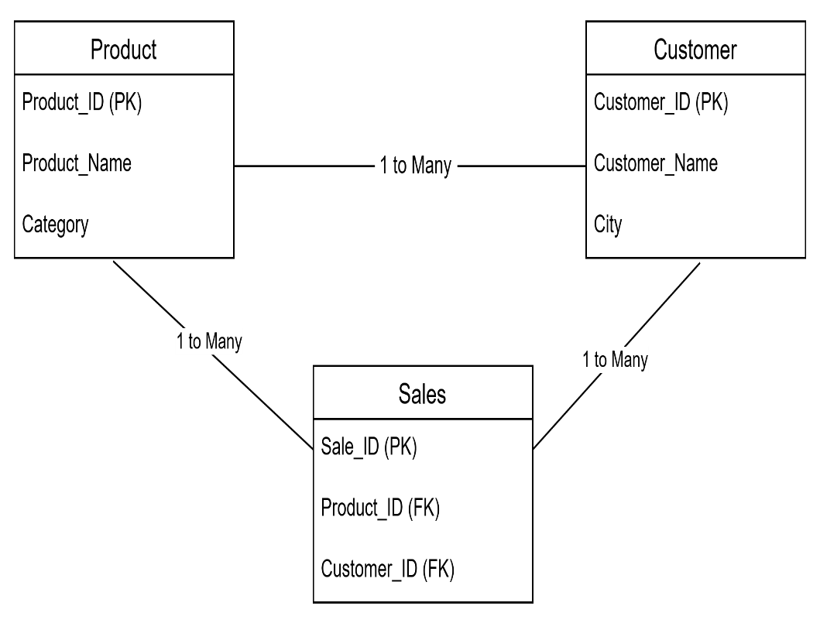
8.1. ER Diagram

Entities:
- Product
- Customer
- Sales
Relationships:
- Product → Sales (1 to many)
- Customer → Sales (1 to many)
b. Use Case Diagram
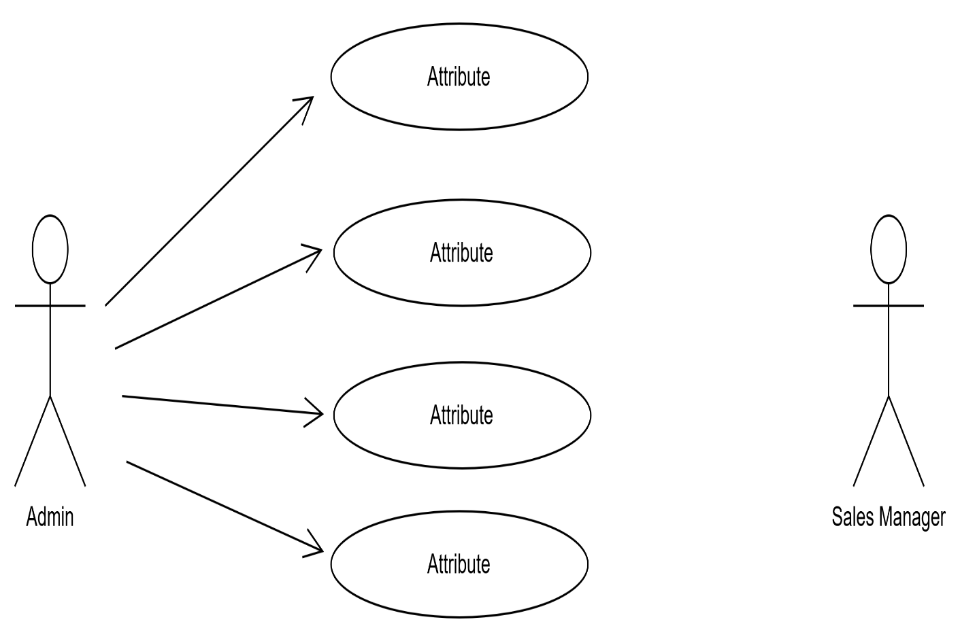
8.2. Use Case Diagram

Actors:
- Admin
- Sales Manager
Use Cases:
- Add Sales Data
- View Sales Summary
- Generate Report
- Analyze Sales
c. Activity Diagram
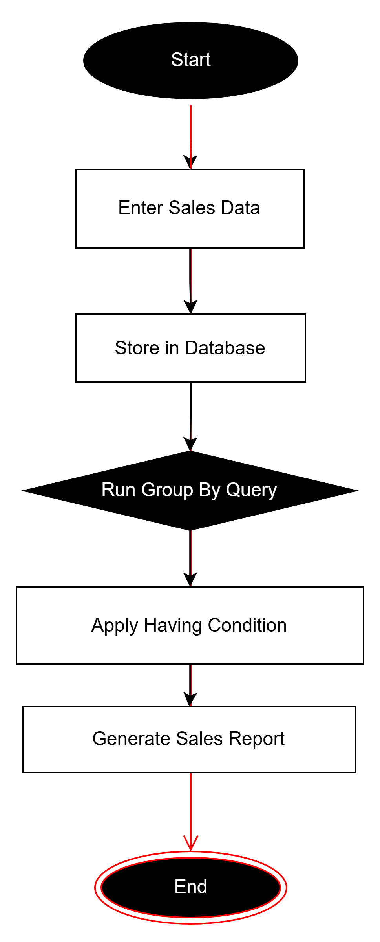
8.3. Activity Diagram

d. Sequence Diagram

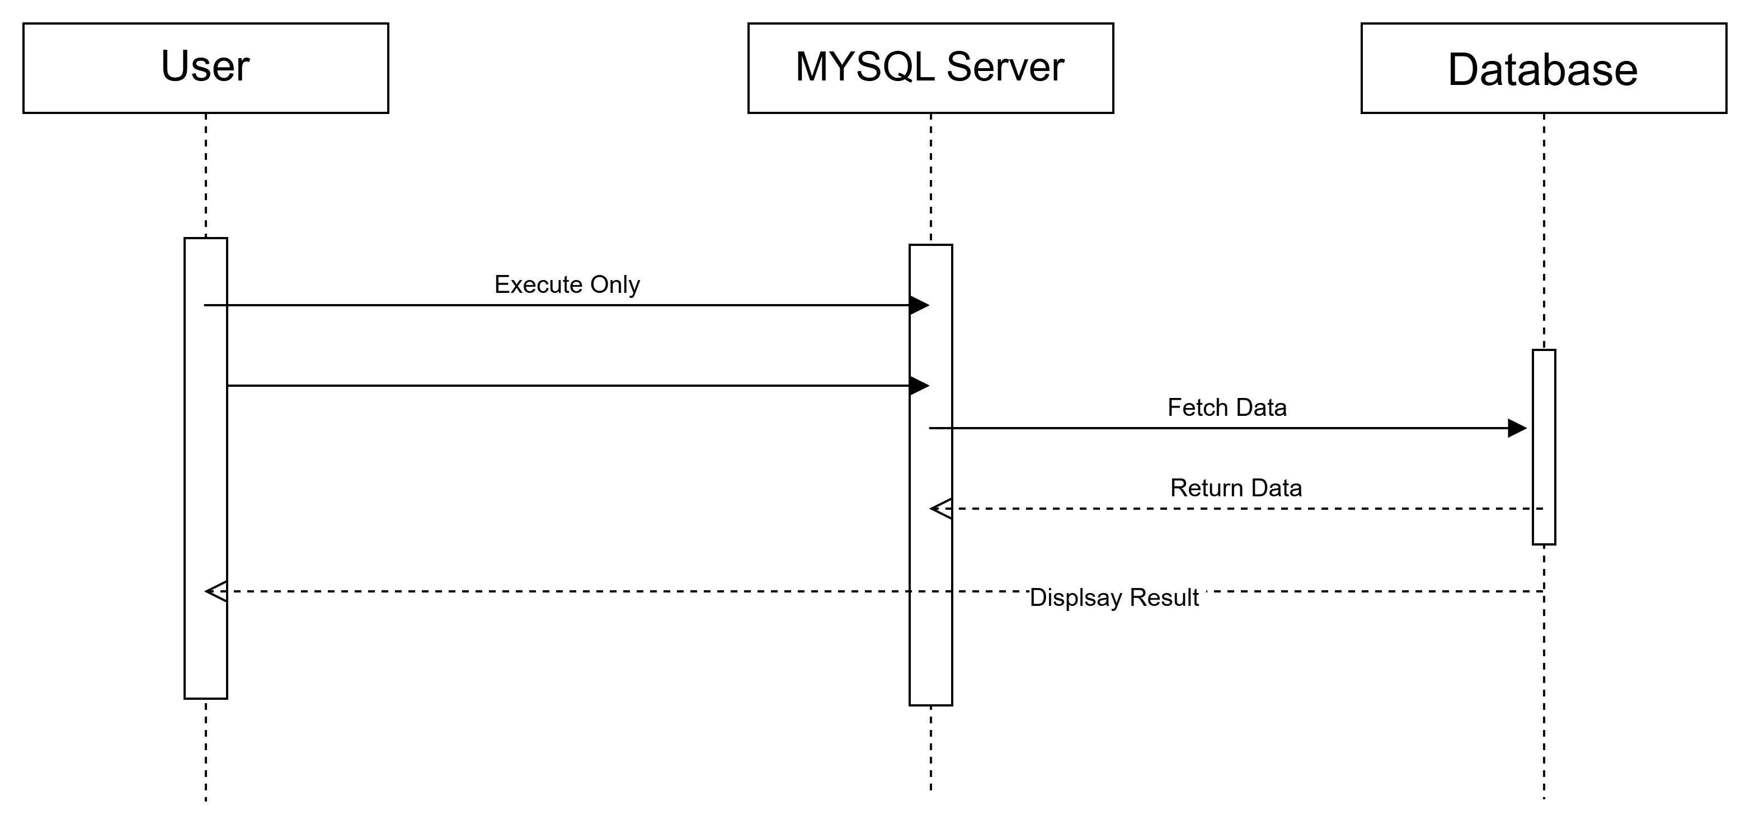
8.4. Sequence Diagram

9. SQL Implementation
9.1 Database Creation
CREATE DATABASE SalesAnalysis;
USE SalesAnalysis;
9.2 Table Creation
CREATE TABLE Product(
Product_ID INT PRIMARY KEY,
Product_Name VARCHAR(50),
Category VARCHAR(50)
);
CREATE TABLE Customer(
Customer_ID INT PRIMARY KEY,
Customer_Name VARCHAR(50),
City VARCHAR(50)
);
CREATE TABLE Sales(
Sale_ID INT PRIMARY KEY,
Product_ID INT,
Customer_ID INT,
Quantity INT,
Total_Amount DECIMAL(10,2),
Sale_Date DATE,
FOREIGN KEY(Product_ID) REFERENCES Product(Product_ID),
FOREIGN KEY(Customer_ID) REFERENCES Customer(Customer_ID)
);

9.3 Data Insertion
INSERT INTO Product VALUES
(1,'Laptop','Electronics'),
(2,'Mobile','Electronics');
INSERT INTO Customer VALUES
(101,'Rahul','Mumbai'),
(102,'Anita','Pune');
INSERT INTO Sales VALUES
(1,1,101,2,100000,'2024-01-10'),
(2,2,102,1,30000,'2024-01-12'),
(3,1,102,1,50000,'2024-01-15');
9.4 GROUP BY Query
SELECT Product_ID, SUM(Total_Amount) AS Total_Sales
FROM Sales
GROUP BY Product_ID;
9.5 HAVING Query
SELECT Product_ID, SUM(Total_Amount) AS Total_Sales
FROM Sales
GROUP BY Product_ID
HAVING SUM(Total_Amount) > 50000;

10. SYSTEM TESTING AND RESULT
System testing is the process of verifying that the Sales Data Analysis System functions correctly, meets project objectives, and produces accurate results. The goal is to ensure the database, SQL queries, and reports work as expected under different scenarios. Testing helps identify errors, validate constraints, and confirm that GROUP BY and HAVING operations provide correct summaries and filtered results.
a. Query Testing
- All SQL queries created for the system were executed and verified.
- Queries included:
  - CREATE: For creating tables and database
  - INSERT: For adding sample data
  - SELECT: To retrieve data
  - GROUP BY: To summarize sales data
  - HAVING: To filter grouped data
- Each query produced expected results without any syntax or runtime errors.
Example Testing Result:
SELECT Product_ID, SUM(Total_Amount) AS Total_Sales
FROM Sales
GROUP BY Product_ID;
Output:
Product_ID | Total_Sales
1 | 150000
2 | 30000

b. Constraint Validation
- Primary Key Constraints: Ensured uniqueness of Product_ID, Customer_ID, and Sale_ID.
- Foreign Key Constraints: Maintained relationships between Product → Sales and Customer → Sales.
- NOT NULL Constraints: Ensured essential fields like Quantity and Total_Amount always contain values.
- UNIQUE Constraints: Prevented duplicate entries in key columns.
Outcome: Only valid and consistent data was stored in the database.

c. Sample Output Verification
- Sample data was inserted into all tables.
- Multiple JOIN queries tested combined results:
SELECT Product_Name, Customer_Name, Total_Amount
FROM Sales
JOIN Product ON Sales.Product_ID = Product.Product_ID
JOIN Customer ON Sales.Customer_ID = Customer.Customer_ID;
Output displayed:
Product_Name | Customer_Name | Total_Amount
Laptop | Rahul | 100000
Mobile | Anita | 30000
Laptop | Anita | 50000
- Verified that GROUP BY and HAVING queries provided accurate summaries and filtered data:
SELECT Product_ID, SUM(Total_Amount) AS Total_Sales
FROM Sales
GROUP BY Product_ID
HAVING SUM(Total_Amount) > 50000;
Output:
Product_ID | Total_Sales
1 | 150000
d. Report Generation Result
- Using SQL queries, the system successfully generated reports showing:
  - Total sales per product
  - Total sales per customer
  - Filtered results of high-performing products using HAVING clause
- Reports were accurate, reliable, and ready for decision-making.

e. Final Result
- All objectives of the project were successfully achieved:
  - Database design is correct
  - Data integrity and relationships maintained
  - SQL queries execute properly
  - GROUP BY summarizes data accurately
  - HAVING filters grouped data effectively
  - Reports generated correctly
- The system is ready for practical use to analyze sales data efficiently.

11. SECURITY, BACKUP AND RECOVERY
Security, backup, and recovery are essential components of any database-driven system. For the Sales Data Analysis System, these mechanisms ensure the protection of sensitive sales data, prevent unauthorized access, and allow restoration of data in case of accidental loss or system failure. Proper implementation of these processes guarantees data integrity, confidentiality, and business continuity.

a. Security
Database security is implemented to protect sensitive sales information such as product sales, customer data, and revenue totals. MySQL provides robust security features to control access and permissions:
- User Management
  - Different users can be assigned specific roles depending on their responsibilities.
    - Admin: Full access to create, modify, delete, and query data.
    - Sales Analyst / Manager: Limited access, can only view reports and query sales data.
    - Unauthorized Users: No access to the database.
  - Commands used:
CREATE USER 'analyst'@'localhost' IDENTIFIED BY 'password123';
GRANT SELECT ON SalesAnalysis.* TO 'analyst'@'localhost';
REVOKE ALL PRIVILEGES ON SalesAnalysis.* FROM 'guest'@'localhost';
- Role-Based Access Control
  - Only authorized users can access certain tables or execute specific SQL commands.
  - Sensitive operations like INSERT, UPDATE, and DELETE are restricted to Admin users only.
- Data Protection
  - Important fields like Total_Amount and Customer_Name are protected to prevent misuse or tampering.
  - Prevents accidental deletion or modification of sales data.
- Audit Trail (Optional Enhancement)
  - Can log user activity to track who accessed or modified data. This ensures accountability and traceability.

b. Backup
Regular backup is crucial to prevent data loss due to:
- System crashes
- Accidental deletion
- Hardware failures
Methods for Backup:
- mysqldump Utility (Command-Line Backup)
  - Exports the database structure and data into a SQL file.
  - Example:
mysqldump -u root -p SalesAnalysis > SalesAnalysis_Backup.sql
  - This file can be stored safely and used to restore the database at any time.
- Scheduled Backup
  - Backups can be scheduled daily or weekly to ensure minimal data loss.
  - Stored on secure storage drives or cloud storage for redundancy.
- Incremental Backup
  - Only changes since the last backup are saved, reducing storage requirements.

c. Recovery
Recovery ensures that the system can be restored quickly if data is lost or corrupted.
- Restoring Database
  - Use the backup SQL file to recreate the database:
mysql -u root -p SalesAnalysis < SalesAnalysis_Backup.sql
  - This restores all tables, relationships, and records exactly as they were at the time of backup.
- Testing Recovery
  - Regularly test recovery processes to ensure backups are valid.
  - Verifies that all data, including sales summaries, grouped reports, and HAVING filters, can be restored.
- Business Continuity
  - Ensures the organization can continue sales analysis without data loss.
  - Minimizes downtime and prevents disruption of critical business operations.

d. Conclusion on Security, Backup, and Recovery
Implementing robust security, backup, and recovery mechanisms ensures that the Sales Data Analysis System is:
- Safe from unauthorized access and data tampering
- Reliable, with data integrity maintained
- Resilient, capable of restoring operations quickly in case of failure
These processes guarantee that sensitive sales data remains confidential, accurate, and available, supporting management in effective decision-making and reporting.

12. FUTURE SCOPE AND CONCLUSION
Future Scope
The Sales Data Analysis System using GROUP BY and HAVING is a robust foundation for analyzing and summarizing sales data. However, there are several ways the system can be enhanced and extended in the future to make it more functional, user-friendly, and advanced:
- Web-Based Interface
Currently, the system operates at the database level using SQL queries. In the future, it can be transformed into a web-based application, allowing users to access sales reports and summaries through a browser. This would make it more accessible and convenient, especially for sales managers working remotely.
- Automated Analytics and Dashboards
The system can be upgraded to automatically generate charts, graphs, and dashboards that visualize sales trends, high-performing products, and revenue patterns. This will provide real-time insights and help management make quicker and more informed decisions.
- Integration with ERP or Inventory Systems
By linking the sales database with inventory management or ERP systems, the organization can track stock levels, customer orders, and sales trends simultaneously. This integration will improve operational efficiency and reduce manual effort.
- Advanced SQL Features and Machine Learning
Future enhancements could include:
  - Predictive analytics using historical sales data
  - Trend analysis and demand forecasting
  - Advanced queries for customer segmentation and product performance
- Mobile Application Support
Providing mobile access for managers and sales personnel will allow them to check sales summaries, generate reports, and update sales entries on the go.
- Enhanced Security and User Roles
Additional security features can be implemented, such as two-factor authentication, encryption of sensitive data, and more granular role-based access control, ensuring data confidentiality and protection.
- Cloud Deployment
Hosting the system on the cloud can improve accessibility, scalability, and data redundancy. Cloud-based backups and automated updates will further enhance reliability and reduce administrative overhead.

Conclusion
The Sales Data Analysis System successfully demonstrates the use of MySQL and SQL commands to manage, summarize, and analyze sales data using GROUP BY and HAVING. The project provides a structured approach for storing sales transactions, applying aggregate functions, and generating meaningful reports.
Key outcomes of the project include:
- Proper database design with tables for Product, Customer, and Sales
- Accurate execution of SQL queries to retrieve grouped and filtered data
- Verification of data integrity and relationship constraints
- Generation of reliable sales summaries for informed decision-making
Overall, the project highlights the importance of database-driven analytics in business environments. It not only improves the efficiency of sales reporting but also forms a strong foundation for future development, including automated analytics, web-based access, and integration with other business systems.
In conclusion, this system provides a practical, reliable, and scalable solution for sales data management and analysis, making it a valuable tool for organizations aiming to make data-driven decisions.

13. REFERENCES
The references listed below include official documentation, textbooks, and online resources that were referred to during the design, implementation, and testing of the Sales Data Analysis System. These sources provide guidance on database concepts, SQL commands, data analysis, and best practices for MySQL implementation.
- MySQL Official Documentation, Oracle Corporation – Guide on database creation, SQL queries, GROUP BY & HAVING, and security. https://dev.mysql.com/doc/
- Database Textbooks:
  - Korth, H.F., Silberschatz, A., Sudarshan, S., Database System Concepts, 7th Edition.
  - Elmasri, R., Navathe, S.B., Fundamentals of Database Systems, 7th Edition.
- Online Tutorials: W3Schools SQL Tutorial – Examples of GROUP BY and HAVING. https://www.w3schools.com/sql/
- Diagrams Tool: diagrams.net (draw.io) – Used for ER, Use Case, Activity, and Sequence diagrams.
- Software Tools: MySQL Workbench – For database testing, query execution, and report generation.

14. GLOSSARY
- Database: A structured collection of data stored electronically, which can be easily accessed, managed, and updated. In this project, it stores sales, product, and customer data.
- MySQL: An open-source relational database management system (RDBMS) used to create, manage, and query databases using SQL.
- SQL (Structured Query Language): A standard language used to communicate with a database. Used to create tables, insert data, retrieve information, and perform analysis.
- GROUP BY: An SQL clause used to group rows with the same values in one or more columns, often used with aggregate functions like SUM, COUNT, AVG, etc., to summarize data.
- HAVING: An SQL clause used to filter the results of a GROUP BY query based on a condition, similar to WHERE but applied to grouped data.
- Aggregate Functions: Functions in SQL that perform calculations on multiple rows and return a single value, such as SUM(), COUNT(), AVG(), MIN(), and MAX().
- Primary Key (PK): A column or set of columns in a table that uniquely identifies each record in that table.
- Foreign Key (FK): A column in one table that refers to the primary key in another table, establishing a relationship between tables.
- Sales Report: A summarized output of sales data, often showing total sales per product, per customer, or filtered by certain conditions.
- Data Integrity: Ensuring that data is accurate, consistent, and reliable within the database.

15. Appendix / SQL Code
CREATE DATABASE SalesAnalysis;
USE SalesAnalysis;
----Create Table
CREATE TABLE Sales (
Sale_ID INT PRIMARY KEY,
Product_Name VARCHAR(50),
Customer_Name VARCHAR(50),
Quantity INT,
Price INT,
Sale_Date DATE
);
----Insert Sample Data
INSERT INTO Sales VALUES
(1, 'Laptop', 'Rahul', 2, 50000, '2024-01-10'),
(2, 'Mobile', 'Anita', 3, 15000, '2024-01-12'),
(3, 'Laptop', 'Suresh', 1, 50000, '2024-01-15'),
(4, 'Tablet', 'Pooja', 2, 20000, '2024-01-18'),
(5, 'Mobile', 'Rahul', 1, 15000, '2024-01-20'),
(6, 'Laptop', 'Anita', 2, 50000, '2024-01-22'),
(7, 'Tablet', 'Suresh', 3, 20000, '2024-01-25');
----Display Table
SELECT * FROM Sales;
- Output:
Sale_ID | Product_Name | Customer_Name | Quantity | Price | Sale_Date
1 | Laptop | Rahul | 2 | 50000 | 2024-01-10
2 | Mobile | Anita | 3 | 15000 | 2024-01-12
3 | Laptop | Suresh | 1 | 50000 | 2024-01-15
4 | Tablet | Pooja | 2 | 20000 | 2024-01-18
5 | Mobile | Rahul | 1 | 15000 | 2024-01-20
6 | Laptop | Anita | 2 | 50000 | 2024-01-22
7 | Tablet | Suresh | 3 | 20000 | 2024-01-25

----GROUP BY (Total Sales per Product)
SELECT Product_Name, SUM(Quantity * Price) AS Total_Sales
FROM Sales
GROUP BY Product_Name;
- Output:
Product_Name | Total_Sales
Laptop | 250000
Mobile | 60000
Tablet | 100000

----GROUP BY (Total Quantity Sold per Product)
SELECT Product_Name, SUM(Quantity) AS Total_Quantity
FROM Sales
GROUP BY Product_Name;
- Output:
Product_Name | Total_Quantity
Laptop | 5
Mobile | 4
Tablet | 5

----HAVING (Products with Sales > 100000)
SELECT Product_Name, SUM(Quantity * Price) AS Total_Sales
FROM Sales
GROUP BY Product_Name
HAVING SUM(Quantity * Price) > 100000;
- Output:
Product_Name | Total_Sales
Laptop | 250000

----HAVING (Products with Quantity ≥ 5)
SELECT Product_Name, SUM(Quantity) AS Total_Quantity
FROM Sales
GROUP BY Product_Name
HAVING SUM(Quantity) >= 5;
- Output:
Product_Name | Total_Quantity
Laptop | 5
Tablet | 5

----Count Customers per Product
SELECT Product_Name, COUNT(Customer_Name) AS Total_Customers
FROM Sales
GROUP BY Product_Name;
- Output:
Product_Name | Total_Customers
Laptop | 3
Mobile | 2
Tablet | 2

----HAVING with COUNT
SELECT Product_Name, COUNT(Customer_Name) AS Total_Customers
FROM Sales
GROUP BY Product_Name
HAVING COUNT(Customer_Name) > 2;
- Output:
Product_Name | Total_Customers
Laptop | 3

